

* Assignment No 3
* Name : Hamza Mehmood
* Roll No: SP21110
* Subject: Information Security
* Class: BSSE-6 Semester-Afternoon
* Submitted to : Dr Zia ur Rehman

Code:

#include <stdio.h>

#include <string.h>

int main(void)

{

char buff[15];

int pass = 0;

printf("\n Enter the password : \n");

gets(buff);

if(strcmp(buff, "Adnan"))

{

printf ("\n Wrong Password \n");

}

else

{

printf ("\n Correct Password \n");

pass = 1;

}

if(pass)

{

/* Now Give root or admin rights to user*/

printf ("\n Root privileges given to the user \n");

}

return 0;

}

**Output:**

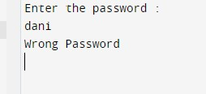

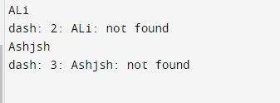

**Correceted Result:**

